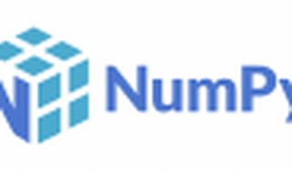



Explore

**NumPy** is the fundamental package for scientific computing with Python. It provides powerful N-dimensional arrays, comprehensive mathematical functions, random number generators, linear algebra routines, Fourier transforms, and more. NumPy’s vectorization, indexing, and broadcasting concepts are widely used in array computing today. [It’s open source, well-optimized, and interoperable with various hardware and computing platforms1](https://numpy.org/).

Here are **five free reference links** where you can learn more about NumPy:

1. [**NumPy Official Website**](https://numpy.org/): The official NumPy website offers documentation, tutorials, and examples to get you started with this essential library[1](https://numpy.org/).
2. [**NumPy on PyPI**](https://pypi.org/project/numpy/): You’ll find the latest version, project description, and source code for NumPy here[2](https://pypi.org/project/numpy/).
3. [**NumPy Tutorial on W3Schools**](https://www.w3schools.com/python/numpy/default.asp): This tutorial covers the basics of NumPy, including working with arrays and various functions[3](https://www.w3schools.com/python/numpy/default.asp).
4. [**NumPy Documentation**](https://numpy.org/doc): Dive deeper into NumPy’s features, functions, and usage through the official documentation[1](https://numpy.org/).
5. [**NumPy Ecosystem**](https://numpy.org/): Explore related tools and libraries that work seamlessly with NumPy, such as Dask, CuPy, JAX, and Xarray[1](https://numpy.org/).

Happy learning! 🚀🐍